

ENDURO_RR_125_2T_MY22
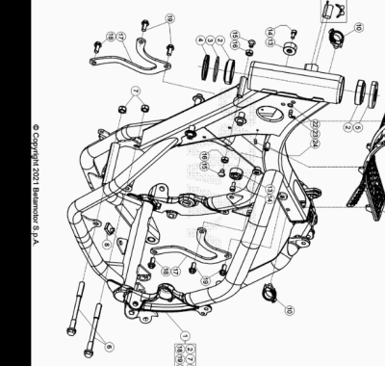

ENDURO_RR_125_2T_MY22
Ref. | Part Number | Description | Part
1 | 041.31.017.80.50 | CHASIS RR 2T | 1
2 | 12.99510.000 | COJINETE CÓNICO 29X50X15 RR-4T | 2
3 | 10.66935.000 | JUNTA TÓRICA RR-4T | 1
4 | 020.31.039.00.00 | GUARDAPOLVO DIRECCION | 1
5 | 031.31.016.22.00 | PROTECCION COJINETE | 1
6 | 11.64607.000 | TORNILLO ESPECIAL RR-4T | 2
7 | 13.21060.000 | TUERCA AMBRIDADA M10 X 1,25 | 2
8 | 25.60311.000 | GRAPA TORNILLO M6 ALP 4.0 2008 | 1
9 | 037.31.024.00.00 | CERRADURA BLOCAJE | 1
10 | 25.24441.000 | PASACABLES | 2
11 | 037.31.071.00.59 | GOMA PROTECTOR DEPOSITO | 1
13 | 29.10310.000 | TOPE GOMA DEPOSITO TR-34/RR-4T | 2
14 | 31.31050.000 | TORNILLO ALLEN TCCE 6.15 | 2
15 | 31.64020.000 | #31.63890.000# | 2
16 | 13.16000.000 | TUERCA 8.6 CH13 | 2
17 | 041.32.000.50.00 | SOPORTE MOTOR RR 2T 125 | 2
18 | 11.54492.000 | TORNILLO CH 8.20 X 10 ENDURO RR 125 | 2
19 | 11.54521.000 | TORNILLO 8.16 RS C/ARANDELA CH.10 | 4
22 | 27.33741.000 | REMACHE | 1
23 | 27.23470.000 | RACORD MOTOR RK6-50/ TUBO GASOLINA RR-T/ART - RR-4T- RR 125 | 1
24 | 25.24443.000 | GUIA CABLE 6/6 RR-4T / RR 125 / RR-T | 1

ENDURO_RR_125_2T_MY22
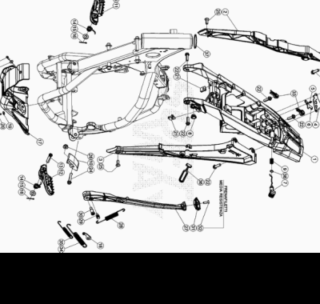

ENDURO_RR_125_2T_MY22
Ref. | Part Number | Description | Part
1 | 040.32.035.80.59 | CHASIS POSTERIOR | 1
2 | 037.32.033.87.59 | SOPORTE SUBCHASIS | 1
3 | 037.32.034.87.59 | SOPORTE COLA TRASERA | 1
4 | 020.32.010.00.05 | CHAPA FIJ. CERRADURA | 1
5 | 020.32.112.00.00 | EJE CERRADURA | 1
6 | 037.32.013.50.00 | SOPORTE | 1
7 | 037.32.014.87.59 | PULSANTE ASIENTO | 1
8 | 037.38.003.00.00 | SOPORTE | 1
9 | 020.32.016.00.00 | MUELLE | 1
10 | 25.25601.000 | PATIN TENSOR RR 4T 2008 | 1
11 | 037.32.009.00.00 | ESTRIBERA DX | 1
12 | 037.32.008.00.00 | ESTRIBERA SX | 1
13 | 25.54465.000 | EJE ESTRIBERA RR-4T | 2
14 | 037.32.019.00.00 | MUELLE | 2
15 | 031.32.001.00.00 | ARANDELA 10 X 21 X 2 | 2
16 | 12.81993.000 | PASADOR EJE ESTRIBERA | 2
17 | 041.32.004.00.59 | PROTECCION MOTOR RR 2T | 1
18 | 037.32.031.50.00 | SOPORTE MUELLE CABALLETE | 1
19 | 27.42000.000 | ARANDELA PLANA 6.18 | 2
20 | 11.49070.000 | TORNILLO 6X20 RS CH8 | 2
21 | 25.60311.000 | GRAPA TORNILLO M6 ALP 4.0 2008 | 2
22 | 31.64070.000 | TORNILLO ESPECIAL 8X25 CH10 | 6
23 | 31.29810.000 | TORNILLO TBCE 5.12 | 2
24 | 11.55480.000 | TORNILLO 8.40 PF C/ARANDELA | 1
25 | 007.32.032.00.00 | TORNILLO ESP. TSBEI CH6 M8X20 10.9 ZINC | 2
26 | 13.17120.000 | TUERCA M8 BASE CILINDRO | 1
27 | 037.32.010.82.00 | KIT CABALLETE | 1
28 | 037.32.030.00.00 | MUELLE | 1
29 | 11.66615.000 | TORNILLO ESP. CAVALLETE RR 4T 2008 | 1
30 | 11.66614.000 | TORNILLO ESPECIAL CABALLETE RR 4T 2008 | 1
31 | 037.32.017.00.00 | SOPORTE | 1
32 | 31.34400.000 | TORNILLO 6 X 20 | 1
33 | 037.32.027.00.00 | KIT TAPON | 1
34 | 037.32.029.00.00 | MUELLE | 1
35 | 037.32.028.00.00 | MUELLE | 1
36 | 16.34907.000 | GOMA CABALLETE RR-4T | 1
37 | 031.32.007.00.00 | ANILLO DE SELLADO | 1
38 | C02.06.066.00.00 | RETEN 9.52 X 1.78 | 1

ENDURO_RR_125_2T_MY22
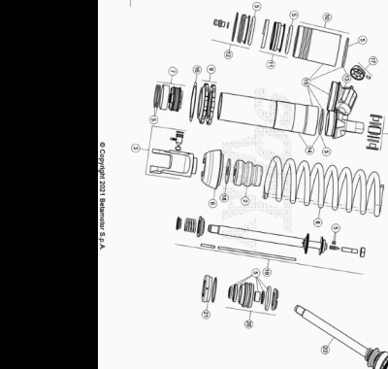

ENDURO_RR_125_2T_MY22
Ref. | Part Number | Description | Part
1 | 041.33.005.80.00 | AMORTIGUADOR RR 2T | 1
2 | 037.33.009.00.00 | TAPON AMORTIGUADOR | 1
3 | 037.33.010.00.00 | HORQUILLA AMORTIGUADOR | 1
4 | 13.86078.800 | KIT DISTANCIADOR AMORTIGUADOR RRT-4T-GR | 1
5 | 037.33.011.82.00 | KIT JUNTAS | 1
6 | 037.33.012.00.00 | TAPON AMORTIGUADOR | 1
7 | 026.33.020.00.00 | PISTON | 1
8 | 041.33.009.00.00 | MUELLE AMORTIGUADOR | 1
9 | 026.33.019.00.00 | TUERCAS AMORTIGUADOR | 1
10 | 026.33.012.00.00 | DEPOSITO AMORTIGUADOR | 1
11 | 026.33.013.00.00 | MEMBRANA | 1
12 | 026.33.014.00.00 | TAPON | 1
13 | 037.33.013.00.00 | TAPON | 1
14 | 037.33.014.00.00 | CUERPO AMORTIGUADOR | 1
15 | 037.33.015.00.00 | CUERPO AMORTIGUADOR | 1
16 | 031.33.012.00.00 | ARANDELA | 1
17 | 026.33.021.00.00 | TAPON REGISTRO | 1
18 | 031.33.014.00.00 | ARANDELA | 1
19 | 037.33.016.00.00 | VARILLA | 1
20 | 037.33.017.00.00 | GUIA | 1
21 | 026.33.026.00.00 | TAPON | 1
22 | 041.33.010.80.00 | VARILLA COMPLETA | 1

ENDURO_RR_125_2T_MY22
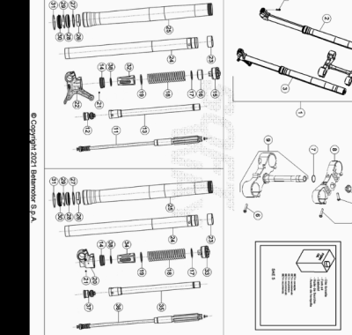

ENDURO_RR_125_2T_MY22
Ref. | Part Number | Description | Part
1 | 041.34.033.80.00 | HORQUILLA COMPLETA | 1
2 | 041.34.027.80.00 | BRAZO DERECHO | 1
3 | 041.34.028.80.00 | BRAZO IZQUIERDO | 1
4 | 020.34.004.00.00 | TUERCA M 20 X 1,5 HORQUILLA RR 4T MY 10 | 1
5 | 11.55440.000 | TORNILLO C/HEX. 10 M8x30 DIN 933 8.8 | 1
6 | 11.55510.000 | TORNILLO 8.40 ALP 200/08 | 8
7 | 10.66420.000 | ANILLO OR 22-3,53 NBR | 1
8 | 031.34.051.42.59 | PLETINA INF | 1
9 | 031.34.041.82.59 |  | 1
10 | 031.34.072.00.00 | TORNILLO M 8.25 8.8 | 4
11 | 041.34.031.00.00 | GRUPO EXTENSION | 1
12 | 040.34.047.00.00 | GRUPO COMPRESION | 1
13 | 037.34.015.00.00 | TUBO | 1
14 | 020.34.313.00.00 | ANILLO DE APOYO VARILLA+ O.RING | 2
15 | 040.34.050.00.00 | TAPON HORQUILLA | 1
16 | 040.34.008.00.00 | DISTANCIADOR | 1
17 | 031.34.323.00.00 | ARANDELA | 2
18 | 035.34.015.00.00 | MUELLE | 2
19 | 040.34.041.00.00 | ARANDELA | 2
20 | 037.34.014.00.00 | PIE HORQUILLA | 1
21 | 020.34.308.00.00 | CLAVIJA | 2
22 | 037.34.013.00.00 | PIE HORQUILLA | 1
23 | 020.34.320.00.00 | CASQUILLO 049/47 L 20 | 2
24 | 031.34.021.00.00 | BARRA HORQ,. RR 2T/4T | 2
25 | 040.34.040.00.00 | BOTELLA HORQUILLA RR 2T | 2
26 | 031.34.020.00.00 | DISTANCIADOR D.52/48 L12 | 2
27 | 020.34.318.00.00 | DISTANCIADOR | 2
28 | 020.34.317.00.00 | RETEN HORQUILLA 48X58X9/11,5 | 2
29 | 020.34.316.00.00 | SEEGER 58,45 | 2
30 | 020.34.315.00.00 | GUARDAPOLVO HORQUILLA | 2
31 | 026.34.364.00.00 | ANILLO BLOQUEO | 2
32 | 040.34.042.00.00 | GUIA MUELLE | 1
33 | 040.34.051.00.00 | TAPON HORQUILLA | 1
34 | 040.34.043.00.00 | GUIA MUELLE | 1
35 | 037.34.016.00.00 | TUBO | 1
36 | 041.34.032.00.00 | GRUPO EXTENSION | 1
37 | 040.34.048.00.00 | GRUPO COMPRESION | 1
38 | 040.34.044.00.00 | ARANDELA | 2

ENDURO_RR_125_2T_MY22
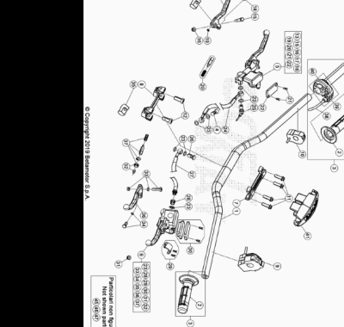

ENDURO_RR_125_2T_MY22
Ref. | Part Number | Description | Part
1 | 037.35.000.00.59 | MANILLAR | 1
2 | 036.35.005.00.00 | JUEGO DE PUÑOS ENDURO | 1
3 | 026.35.002.80.00 |  | 1
4 | 11.65053.000 | TORNILLO ESPECIAL TALAD.10..1,25 RR-4T | 1
5 | 21.02057.059 | BOMBA FRENO DELANTERA RR4T RACING | 1
6 | 020.35.020.00.00 | BOMBA EMBRAGUE ENDURO RR 4T 2012 | 1
7 | 12.08253.000 | ABRAZADERA SUPERIOR HORQUILLA RR-4T | 1
8 | 12.08263.000 | ABRAZADERA INF HORQUILLA RR4T 1508050 | 1
9 | 016.35.010.00.00 | MANDO LUCES CON INTERMITENTES ENDURO 2017 | 1
10 | 035.35.003.00.00 | DISPOSITIVO ON-OFF | 1
11 | 31.64070.000 | TORNILLO ESPECIAL 8X25 CH10 | 4
12 | 31.65626.000 | TORNILLO 10X25 RR-4T | 2
13 | 21.27104.000 | MANETA FRENO ANT. FORJADA RR 4T | 1
15 | 31.96832.000 | PASADOR MANETA FRENO | 1
16 | 13.30911.000 | TUERCA PASADOR MANETA FRENO | 1
17 | 16.33841.000 | GOMA RR 4T 2008 | 1
18 | 31.88604.000 | TORINILLO REG | 1
19 | 22.38704.000 | MUELLE REG. BOMBA FRENO | 1
20 | 20.08258.000 | JUEGO PISTON COMPL. BOMBA FRENO ANT. RR-4T | 1
21 | 31.23410.052 | TORNILLO TAPA DEP. LIQUIDO FRENOS | 2
22 | 031.36.003.82.00 | KIT TAPA BOMBA FRENO ANT. RR2T | 1
23 | 16.50510.000 | JUNTA 10.15.1 (COBRE) | 7
24 | 037.36.002.00.00 | TUBO FRENO | 1
25 | 18.89621.000 | INTERRUPTOR STOP RR-4T | 1
26 | 11.65040.000 | TORNILLO ESP. TALAD.10.1 PARA TUBO FRENO | 1
27 | 035.35.002.00.00 | TUBO EMBRAGUE | 1
28 | 020.35.032.00.00 | RACORD BOMBA EMBRAGUE | 1
29 | 020.35.025.00.00 | BRIDA | 1
30 | 020.35.023.00.00 | TAPA DEPOSITO BOMBA EMBRAGUE | 1
31 | 020.35.028.00.00 | ANTIEMULSION | 1
32 | 020.35.029.00.00 | VARILLA DE PRESION | 1
33 | 020.35.024.00.00 | EJE PALANCA | 1
34 | 020.35.030.00.00 | GUIA RESORTE | 1
35 | 020.35.027.00.00 | GOMA PROTECCION PALANCA | 1
36 | 020.35.022.00.00 | MANETA EMBRAGUE RR4T 2012 | 1
37 | 020.35.026.00.00 | KIT PISTON BOMBA | 1
38 | 026.35.011.82.00 | CABLE MANDO GAS | 1
39 | 026.35.010.00.00 | #12.55098.000# | 1
40 | 031.35.013.00.00 | PROTECCION | 1
41 | 037.43.016.00.59 | PROTECCION MANILLAR | 1
45 | 12.30100.000 | SOPORTE MANETA FRENO ANT (ESPEJO) | 1
46 | 28.92927.000 | #28.92927.800# | 1
47 | 031.35.008.00.00 | RETROVISOR SX | 1

